**AIM**: A program to implement DDA Line Drawing Algorithm

Program & Output

ALGORITHM

#include <graphics.h>

#include <stdio.h>

#include <math.h>

#include <dos.h>

void main( )

{ float x,y,x1,y1,x2,y2,dx,dy,step;

int i,gd=DETECT,gm;

initgraph(&gd,&gm,"c:\\turboc3\\bgi");

printf("Enter the value of x1 and y1 : ");

scanf("%f%f",&x1,&y1);

printf("Enter the value of x2 and y2: ");

scanf("%f%f",&x2,&y2);

dx=abs(x2-x1);

dy=abs(y2-y1);

if(dx>=dy)

step=dx;

else

step=dy;

dx=dx/step;

dy=dy/step;

x=x1;

y=y1;

i=1;

while(i<=step)

{

putpixel(x,y,5);

x=x+dx;

y=y+dy;

i=i+1;

delay(100);

}

closegraph();

}

// calculate dx, dy

dx = x2 – x1;

dy = y2 – y1;

// choose number of steps to put pixel as

// steps = abs(dx) > abs(dy) ? abs(dx) : abs(dy)

steps = abs(dx) > abs(dy) ? abs(dx) : abs(dy);

// calculate increment in x & y for each steps

Xinc = dx / (float) steps;

Yinc = dy / (float) steps;

// Put pixel for each step

X = x1;

Y = y1;

for (int i = 0; i <= steps; i++)

{

putpixel (x,y,WHITE);

x += Xinc;

x += Yinc;

}

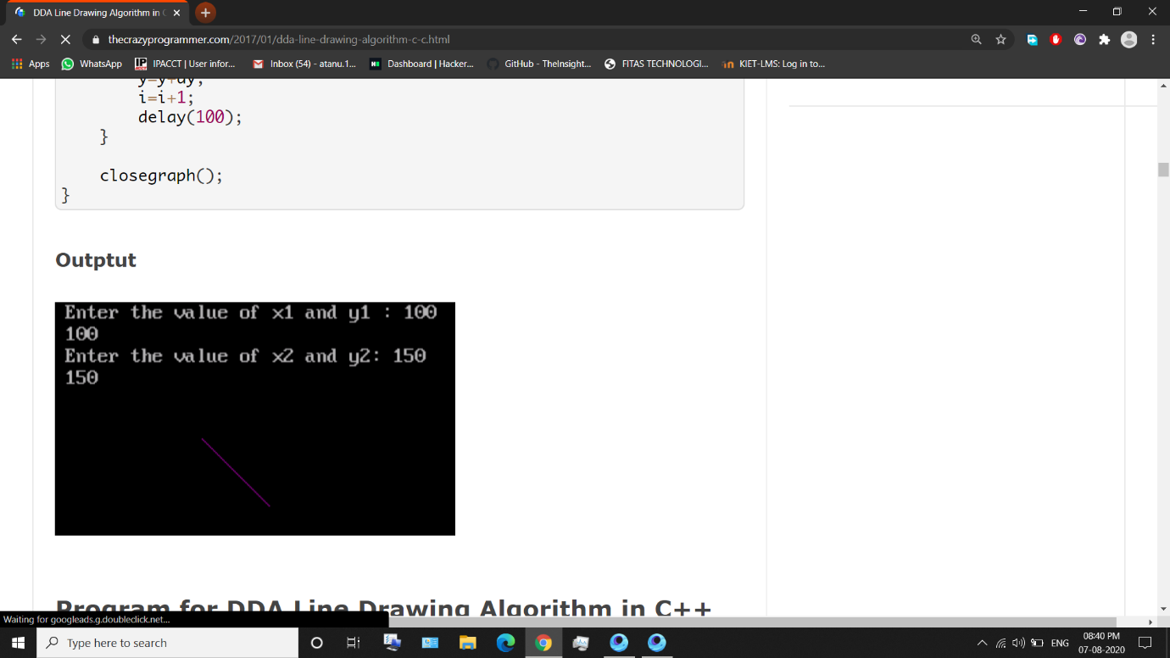

OUTPUT